* The “_main_menu” scene is a basic main menu. Contains two textboxes and a button which loads the game scene when tapped.
* The “_main” scene is the current prototype.

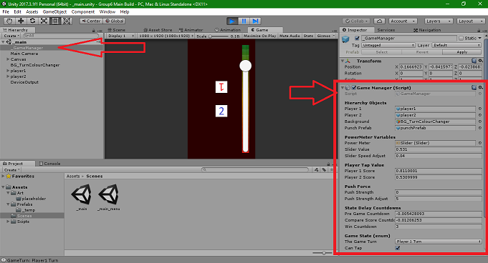

* In the hierarchy of the _main scene is a game object called “_GameManager” (top left arrow)
* _GameManager has the script component “Game Manager” (right arrow and box)
* The Game Manager script houses public variables and is responsible for changing the current game state.
* Clicking on the “Game Turn” dropdown will expand the menu to show all the states the build will cycle through during play.
* **Hopefully seeing the game states will make the build more understandable.**

